**DRIVER’S DROWSINESS DETECTION SYSTEM USING COMPUTER VISION**

***A Report submitted***

***In partial fulfillment for the Degree of***

**B. Tech**

**In**

**Course name**

***By***

**NAME OF THE CANDIDATE(S)**

Pursued in

**Department of <Name of the department/ Division Name>**

To

<University/College logo>

**<UNIVERSITY/ COLLEGE NAME>**

**PLACE**

**MONTH, YEAR**

(The certificate is to be printed on the Institute Letter-Head)

**CERTIFICATE**

This is to certify that the project report entitled Driver’s drowsiness detection system using Computer vision Submitted by <**Name of the candidate>** to the <**Name of College/University**>, in partial fulfillment for the award of the degree of **B. Tech in ( )** is a *bona fide* record of project work carried out by him/her under my/our supervision. The contents of this report, in full or in parts, have not been submitted to any other Institution or University for the award of any degree or diploma.

<Signature> <Signature>

<Name of the supervisor> <Name of the co-supervisor>

Supervisor Co-Supervisor

Department of <Name of the Department of <Name of the

department/Centre> department Centre>

Place Counter signature of HOD with seal

<Month, year>

**DECLARATION**

I declare that this project report titled Driver’s drowsiness detection using Computer visionsubmitted in partial fulfillment of the degree of **B. Tech in ()** is a record of original work carried out by me under the supervision of <**Name(s) of the Supervisor(s)>**, and has not formed the basis for the award of any other degree or diploma, in this or any other Institution or University. In keeping with the ethical practice in reporting scientific information, due acknowledgements have been made wherever the findings of others have been cited.

<Signature>

<Name of the candidate>

<University Roll No

Place

<Date>

**ACKNOWLEDGMENTS**

All acknowledgements to be included here. Please restrict to **two pages**. The name of the candidate shall appear at the end, without signature. I take this opportunity to thank Dr. K. S. Das Gupta, Director - IIST, Dr. Thomas Kurien, Dean –Students Activities, and other faculty members who helped in preparing the guidelines. I extend my sincere thanks to one and all of IIST family for the completion of this document on the project report format guidelines.

<Name of the Candidate>

**ABSTRACT**

It occurs when a driver is so fatigued or sleep-deprived that they are unable to maintain their full attention and alertness while driving. Drowsy driving is a problem that affects drivers of all ages and can occur at any time of day. There are many factors that can contribute to drowsy driving, including lack of sleep, and long driving hours, shift work, and the use of certain medications. Drowsy driving can also be exacerbated by factors such as alcohol or drug use, or underlying medical conditions such as sleep disorders.

The consequences of drowsy driving can be severe, with estimates suggesting that it may be a factor in up to 40% of motor vehicle accidents. To address this issue, we aimed to develop a system for detecting and preventing drowsy driving in real-time by using a combination of hardware and software solutions. On the hardware side, we used a camera to collect data about the driver's behavior and physical state. This included measures such as eye movements, facial expressions, and distance from the camera. On the software side, we developed algorithms to analyze this data in real-time and identify patterns that are indicative of drowsy driving. When drowsy driving is detected, the system can take various actions to alert the driver and prevent an accident from occurring. These actions include sounding an alarm and displaying a warning message. This can prevent an accident from occurring.

Drowsy driving is a serious safety concern that can lead to accidents, injuries, and fatalities on the road.

1. **Introduction**

Drivers fatigue causes maximum number of accidents. Drowsiness detection reduces the car accidents and increases the safety of driver. Various studies states that around 30-40% accidents occur due to drowsy driver. The development of technology allows introducing more advanced solutions in everyday life. This makes work less exhausting for employees, and also increases the work safety. Now a day’s vision-based systems are more popular and it is used in different application. Detection of drowsiness involves an observation of a face, detection of eye position and the observation of eye blinking pattern. The analysis of face images is done by using a “shape predictor containing 68-facelandmarks”. To detect fatigue, a webcam has been used which points directly towards driver face and detect eye movement. In this the project will focus on the blinking pattern of the eyes, which involves looking at the entire image of the face, and determining the position of the eyes, by a self-developed image processing algorithm. Once the position of the eyes is located, the system is designed to determine whether the eyes are opened or closed and detect drowsiness. If the eyes are closed for particular time period the alarm will play to alert the driver.

1. **Rationale**

The development of technologies for detecting or preventing drowsiness at the wheel is a major challenge in the field of accident avoidance systems. Because of the hazard that drowsiness presents on the road, methods need to be developed for counteracting its affects. Driver inattention might be the result of a lack of alertness when driving due to driver drowsiness and distraction. Driver distraction occurs when an object or event draws a person’s attention away from the driving task.

1. **Objectives**

The fundamental goal of the proposed system is to prevent road accidents by alarming drivers in the condition of Drowsiness by playing an alarm.

1. **Literature Review**

Driver Drowsiness Detection System and Techniques: According to the studies it has been observed that when the drivers continuously drive without taking a break, they tend to run a high risk of becoming drowsy. Study shows that accidents occur due to sleepy drivers in need of a rest, which means that road accidents occurs more due to drowsiness rather than drink-driving. Attention assist can warn of inattentiveness and drowsiness in an extended speed range and notify drivers of their current state of fatigue and the driving time since the last break, offers adjustable sensitivity and, if a warning is emitted, indicates nearby service areas in the COMAND navigation system. Implementation of the Driver Drowsiness Detection System: This paper is about making cars more intelligent and interactive which may notify or resist user under unacceptable conditions, they may provide critical information of real time

situations to rescue or police or owner himself. Driver fatigue resulting from sleep disorders is an important factor in the increasing number of accidents on today's roads. In this paper, we describe a real-time safety prototype that controls the vehicle speed under driver fatigue. To advance a system to detect fatigue symptoms in drivers and control the speed of vehicle to avoid accidents is the purpose of such a mode. In this paper, we propose a driver drowsiness detection system in which sensor like eye blink sensor are used for detecting drowsiness of driver.If the driver is found to have sleep, buzzer will start buzzing and then turns the vehicle ignition off. Driver Drowsiness Detection System: One of the major causes of traffic accident is Driver ‘s drowsiness. It is a serious highway safety problem. If drivers could be warned before they became too drowsy to drive safely, some of these crashes could be prevented. In order to reliably detect the drowsiness, it depends on the presentation of timely warnings of drowsiness. To date, the effectiveness of drowsiness detection methods has been limited by their failure to consider individual differences. Based on the type of data used, drowsiness detection can be conveniently separated into the two categories of intrusive and non-intrusive methods. During the survey, non-intrusive methods detect drowsiness by measuring driving behaviour and sometimes eye features, through which camera-based detection system is the best method and so are useful for real world driving situations. This paper presents the review of existed drowsiness detection techniques that will be used in this system like Circular Hough Transform, FCM, and Lab Color Space etc. Drowsiness Detection System Using MATLAB: As the survey done, driver fatigue is the major reason why half (50 %) of road accidents takes place. It is an interesting challenge in today’s date to detect drowsiness in order prevent accidents. Various experiments have been done earlier with regard to the drowsiness detection of driver. In the past few years, many countries became curious to pay high attention towards driver’s safety problems. Researchers have been making various efforts to invent techniques for the detection of drowsy driver such as monitoring of road and physiological techniques which requires the contact of electrode with our body such as chest, face making it an implantable method. Detecting Driver Drowsiness Based on Sensors: Researchers have attempted to determine driver drowsiness using the following measures: (1) vehicle-based measures; (2) behavioural measures and (3) physiological measures. A detailed review on these measures will provide insight on the present systems, issues associated with them and the enhancements that need to be done to make a robust system. This paper reviews the three measures as to the sensors used and discuss the advantages and limitations of each. The various ways through which drowsiness has been experimentally manipulated is also discussed. It is concluded that by designing a hybrid drowsiness detection system that combines non-intrusive physiological measures with other measures one would accurately determine the drowsiness level of a driver. A number of road accidents might then be avoided if an alert is sent to a driver that is deemed drowsy.

1. **Proposed Methodology**

Drowsy Driver Detection System has been developed, using the intrusive machine vision-based concepts. The system uses a web camera that points directly towards the driver’s face and monitors the driver’s eye movements in order to detect fatigue. In such a case when fatigue is detected, a warning signal is issued to alert the driver. The algorithm developed is different from any currently published papers, which was a primary objective of the project. The system deals with detecting eyes within the specific segment of the face. If these are not found for 20 consecutive frames, the system draws the conclusion that the driver is falling asleep. In this project we have developed drowsiness detection system by using Python. The input video is captured by using webcam (camera) and then it will be extracted. The face and eye detection are done by using OpenCV. By using the Euclidean eye aspect ratio, we can get eye blinking ratio, it helps to detect either eyes are open or closed. It will detect the face and eyes of the driver by using the given commands. Then it will detect whether the eyes of driver are open or close. If the eyes are closed more than given time interval it will warn the driver by playing the alarm or if eyes are open it will display message “eyes open” and then it will go to taking the video of driver and the process will go on.

1. **Block Diagram**

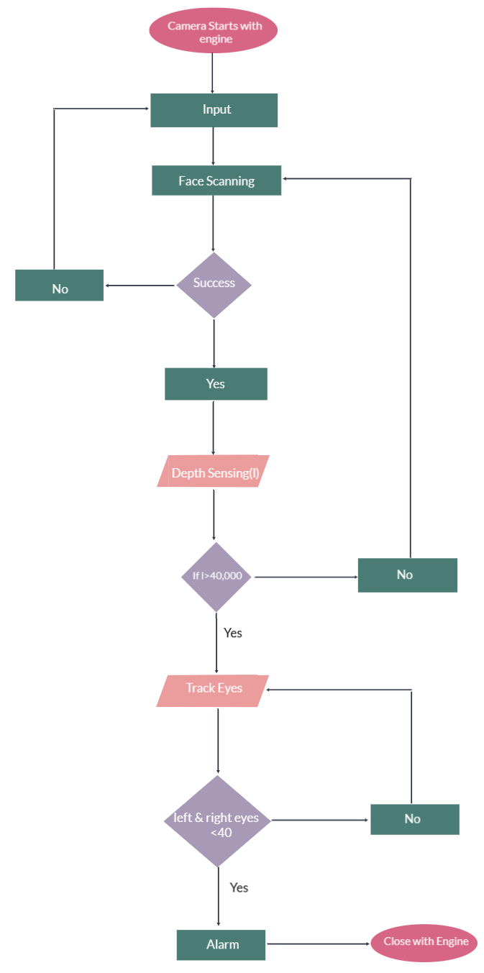

**Figure 1: Block Diagram of the proposed model**

1. **Experimental Setup**

For the purpose of detection and recognition of face Eigen face algorithm is used further PCA is used to classify it. For the detection of eyes, we are using Haar left eye and right eye detection Cascade.

**System configuration (Hardware Requirement):**

**RAM:** 2 GB Ram

**SIZE:** 300 MB of Free space

**CPU:** Intel Pentium Inside

**GPU:** Intel 82945G Express

Software Requirement: No special software is required to run the application

1. **Expected outcomes**

The System can be used to track driver’s Drowsiness. It’ll prevent the road accidents that occurs because of Drowsiness.

1. **Timeline**

